SAMLESKJEMA MAPPESTRUKTUR PRU

NIVÅ 1 ____________________________________________________________________________________

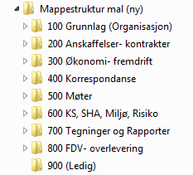

NIVÅ 2 ____________________________________________________________________________________
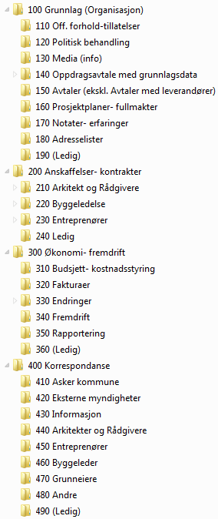
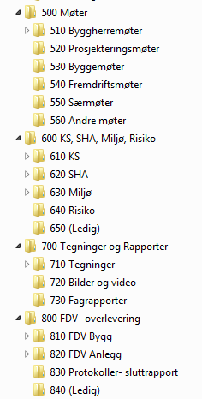

NIVÅ 3
__________________________________________________________________________________

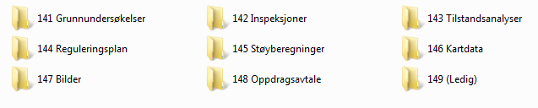

-----

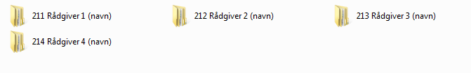
-----

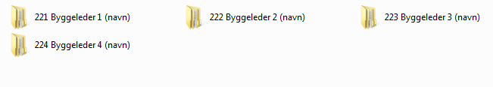
-----

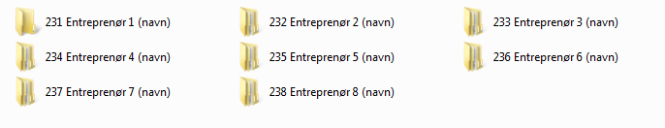

-----

-----

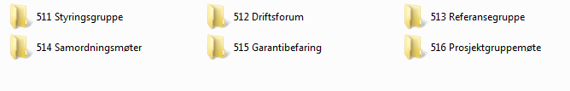
-----

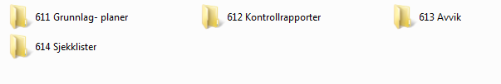
-----

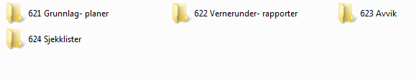
-----

-----

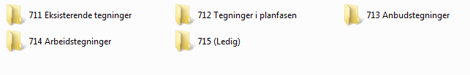

-----
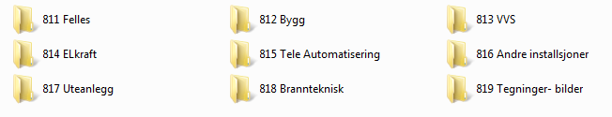

-----


NIVÅ 4
________________________________________________________________________

200 Anskaffelser – Kontrakter:
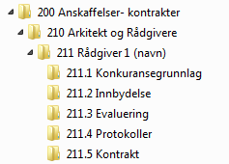

Tilsvarende understruktur finnes for alle mapper under 200 Anskaffelser – Kontrakter

-----
800 FDV- overlevering:
